

**American International University- Bangladesh**

**COE 3103: DATA COMMUNICATION**

**Mid Lab Report 04**

**Spring 2021-2022**

**Section: Q**

**Date: 14/03/2022**

**Submitted by,**

|  |  |
| --- | --- |
| Student Name | Student Id |
| Rahman, Sheikh Talha Jubayer | 19-41468-3 |

**Tasks**

**Class Task:**

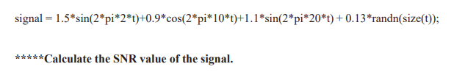

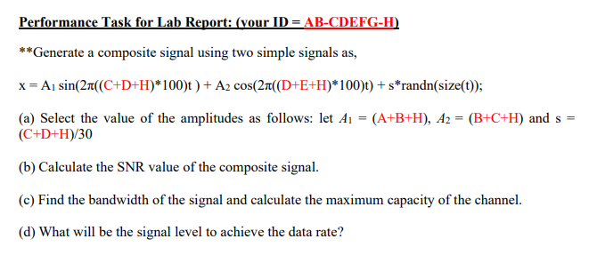

**Solution of Class Task**

fs = 8000; % Sampling frequency

%Define signal

t = 0:1/fs:1-1/fs;

signal = 1.5*sin(2*pi*2*t)+0.9*cos(2*pi*10*t)+1.1*sin(2*pi*20*t) + 0.13*randn(size(t));

%snr

SNR = snr(signal)

Output:

SNR =

1.4244

**Solution of Performance Task (a)**

%ID: 19-41468-3

A = 1;

B = 9;

C = 4;

D = 1;

E = 4;

F = 6;

G = 8;

H = 3;

A1 = (A+B+H)

A2 = (B+C+H)

s =(C+D+H)/30

Output:

A1 =

13

A2 =

16

s =

0.2667

**Solution of Performance Task (b)**

%ID: 19-41468-3

A = 1;

B = 9;

C = 4;

D = 1;

E = 4;

F = 6;

G = 8;

H = 3;

A1 = (A+B+H); %A1 = 13

A2 = (B+C+H); %A2 = 16

s =(C+D+H)/30; %s = 0.2667

fs = 8000; % Sampling frequency

%Define signal

t = 0:1/fs:1-1/fs;

x = A1*sin(2*pi*((C+D+H)*100)*t) + A2*cos(2*pi*((D+E+H)*100)*t) + s*randn(size(t));

%snr

SNR = snr(x)

Output:

SNR =

34.6128

**Solution of Performance Task (c)**

%ID: 19-41468-3

A = 1;

B = 9;

C = 4;

D = 1;

E = 4;

F = 6;

G = 8;

H = 3;

A1 = (A+B+H); %A1 = 13

A2 = (B+C+H); %A2 = 16

s =(C+D+H)/30; %s = 0.2667

fs = 8000; % Sampling frequency

%Define signal

t = 0:1/fs:1-1/fs;

x = A1*sin(2*pi*((C+D+H)*100)*t) + A2*cos(2*pi*((D+E+H)*100)*t) + s*randn(size(t));

%snr

SNR = snr(x);

Bandwidth = obw(x,fs) % Bandwidth of the signal

Capacity = Bandwidth*log2(1+SNR) % Capacity of the channel

Output:

Bandwidth =

0.9903

Capacity =

5.1103

**Solution of Performance Task (d)**

%ID: 19-41468-3

A = 1;

B = 9;

C = 4;

D = 1;

E = 4;

F = 6;

G = 8;

H = 3;

A1 = (A+B+H); %A1 = 13

A2 = (B+C+H); %A2 = 16

s =(C+D+H)/30; %s = 0.2667

fs = 8000; % Sampling frequency

%Define signal

t = 0:1/fs:1-1/fs;

x = A1*sin(2*pi*((C+D+H)*100)*t) + A2*cos(2*pi*((D+E+H)*100)*t) + s*randn(size(t));

%snr

SNR = snr(x);

Bandwidth = obw(x,fs); % Bandwidth of the signal

Capacity = Bandwidth*log2(1+SNR); % Capacity of the channel

Level = floor(2^(Capacity/(2*Bandwidth))) %signal level to achieve the data rate

Output:

Level =

5